Page 8
International and Israeli regulation to reduce risks from PFAS compounds

In 2001, many countries, including Israel, signed the Stockholm Convention - that deals with limiting the distribution of persistent organic pollutants, which accumulate in terrestrial and marine systems and have the ability to migrate over long distances. The convention came into effect in 2004 and is updated from time to time.
As of today, the convention has been ratified by 185 countries that have anchored its provisions in local regulation.
These days the Ministry of Environmental Protection is working for its approval.
The convention includes 30 chemicals and groups of chemicals, some of which are banned for use, production, export, and import (listed in Annex A of the convention) and restrictions on use have been established for the others (listed in Appendix B of the convention).
Compound PFOS and its salts were added in 2009 to Annex B of the Convention, and a decade later, in 2019, the compound PFOA, its salts and related compounds were added to Annex A. The convention prohibits the production of firefighting foams containing PFOA and limits the import and export of firefighting foams containing PFOS and PFOA. It permits emergency use of existing firefighting foams containing these compounds but prohibits their use for training purposes.
The updates regarding PFOS, PFOA, were approved by most countries while some requested a transition period of between 5 to 10 years until achieving the total termination of PFOA firefighting foam use.
In the European Union, the exemption for PFOA is valid until July 2025, while firefighting foams containing PFOS were withdrawn from use in the EU as early as 2011.
PFOS and PFOA are examples of chemicals that require risk management, but there are other chemicals in Israel, as in many countries around the world, whose risks must be studied and limited. To achieve this goal, various mechanisms to systematically register chemicals, assess the risks posed by them, and to properly manage them, have been established in most Western countries during the last two decades.
The Industrial Chemicals Registration Law Memorandum which was published in October 2020 and regulates this mechanism for the first time in Israel, is expected to enter the legislative process in the near future.

Page 9
3 PFAS related environmental pollution in Israel
1 Groundwater and drinking water
The main sources of groundwater and drinking water contamination with flame retardants, which are recognized worldwide, are the manufacturing industry of products based on PFAS compounds and the use of firefighting foams containing PFAS to extinguish large fuel fires at military and civilian airports, central firefighting training sites and landfills.
The high solubility of PFAS compounds in water, combined with the low adsorption capacity of these substances to soil and rock, causes PFAS compounds to reach the groundwater and spread quickly, in a way that could contaminate nearby drinking water production wells.
In recent years, PFAS contamination has been found in drinking water supply systems in the United States and Europe, through which millions of consumers were continuously exposed to significant concentrations of these compounds. For example, in a study recently published in Environmental Science and Technology¹, out from 254 samples collected in 16 states in the eastern United States, it was found that PFAS compounds were present in 20% of private wells and 60% of public wells.
In 2020-2021, the Water Authority and the Ministry of Health conducted a monitoring survey of PFAS compounds in two stages, for the purpose of characterizing the situation in Israel:
- Groundwater - monitoring wells were sampled in potential centers of contamination such as refineries, oil terminals, airports, landfills, and military industry facilities.
- Drinking water production facilities – facilities that are located near pollution centers determined in the first stage and in several other centers were sampled.
The main monitoring findings, shown in Table No. 1, show that very high concentrations of PFAS pollutants were found in the groundwater under the refineries in Haifa and Ashdod, as well as under the oil terminals of TASHAN (Energy and Oil Infrastructures) LTD in Kiryat Haim. Fairly low concentrations were found in the monitoring drilling at the Air Force base in Hazor.
As of today, the reference values for substances from the PFAS family in drinking water that have been adopted by the Ministry of Health - a maximum allowed concentration of 600 ng/L of PFOS and 200 ng/L of PFOA -, are in accordance with the mandatory concentrations established in the Canadian standard.
It is important to note that the maximum permissible threshold values in the USA (70 ng/L) and in the European Union (100 ng/L for single PFAS and 500 ng/L for the total concentration of PFAS) are lower than the values in Canada, but since in these countries the standards are not binding at this point in time, it was decided by the Ministry of Health to recognize the mandatory values in Canada and to consider adopting more stringent values in the future.

Page 10

Table 1 Concentrations of PFAS pollutants (in nanogram/Liter units) in groundwater monitoring wells at selected industrial sites:

Monitoring Site | PFOA | PFOS | PFBS | PFHxA | PFHxS | PFHpA
Recommended time values | 200 | 600 | -- | -- | -- | --
BAZAN Haifa | 1,700 | 230,000 | 13,000 | 16,000 | 64,000 | 640
Pi Glilot | 600 | 3,300 | 800 | 770 | 28,000 | 110
PAZ Ashdod Oil Refineries | 25,000 | 600,000 | 13,000 | 41,000 | 100,000 | 4,900
TASHAN Kiryat Haim | 29,600 | 908,000 | -- | -- | -- | --
Herzliya Airport | 335 | 1,500 | -- | -- | -- | --
Haifa Chemicals North | 5,400 | 24,000 | -- | -- | -- | --

Following these findings, the Water Authority is carrying out groundwater testing to locate the sources of contamination at the TASHAN oil terminal in Kiryat Haim and Ashkelon, at the “Reading” and “Orot Rabin” Power Station terminals, and at the Reading fire station in Tel Aviv. In the coming months, the Water Authority will collect and analyze the findings of the PFAS monitoring drills in all the container terminals in Israel.
In the second phase and following the Water Authority survey, the Ministry of Health sampled drinking water production wells in the Kiryat Haim area. In the samples, no concentrations of PFOS and PFOA exceeding a relative sum value higher than 1 were found, except in one well in Kiryat Haim, where the relative sum value is higher than 1, and therefore the Ministry of Health decided to shut it down.
The maps of refinery sites, show the concentrations of PFOA and PFOS in groundwater and nearby drinking water wells, are shown in diagram 1. The drinking water wells are surrounded by a blue circle inside a red circle (the protective radius around the wells), the red circles (without the blue circle inside) are proportional in size to the PFOS concentrations measured in the drilling.

Page 11
Diagram 1 PFOS (marked in black) and PFOA (marked in blue) concentrations in monitoring wells at fuel infrastructure sites in the Haifa Bay area and in drinking water production wells in their vicinity [micrograms/liter].
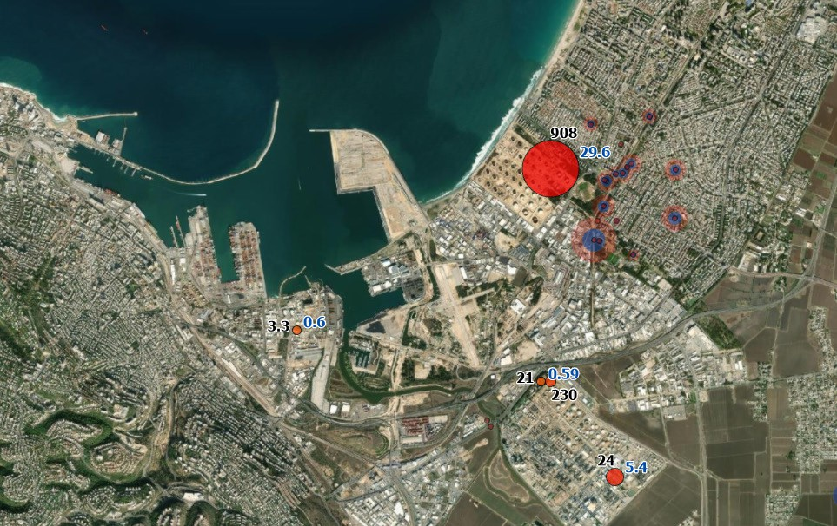
The container terminal in the Haifa Bay area

Kiryat Haim
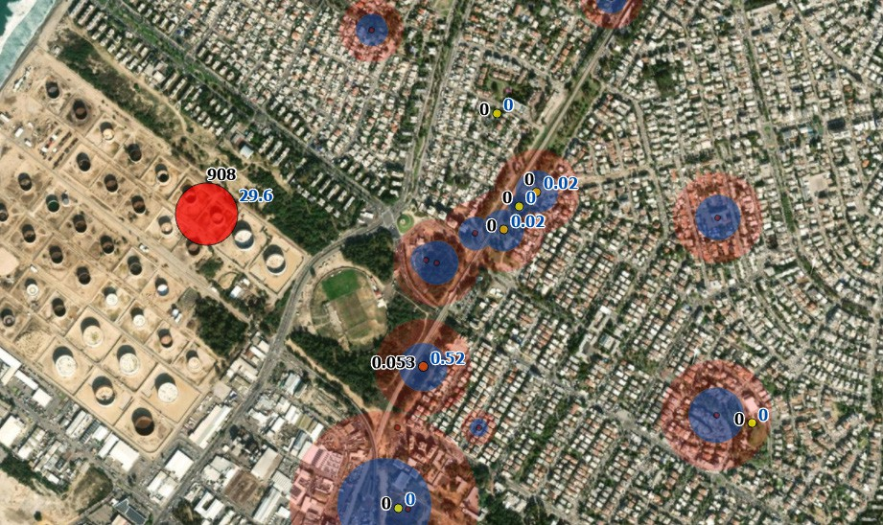

For more information on the Water Authority report - click this link
In the months of December 2021 to February 2022, the Ministry of Health surveyed nine PFAS compounds in 100 drinking water production facilities of the Mekorot company and of private water suppliers, in areas with a risk of contamination. Concentrations of PFAS compounds were measured in 16 wells (above the laboratory reporting limit), but in all of them the concentration was lower than the temporary reference values adopted by the Ministry of Health.

